Python Pillow - Merging Images

Pillow package allows you to paste an image onto another one. The merge() function accepts a mode and a tuple of images as parameters, and combines them into a single image.

Syntax

Image.merge(mode, bands)

Where,

* **mode** − The mode to use for the output image.
* **bands**− A sequence containing one single-band image for each band in the output image. All bands must have the same size.
* **Return value** − An Image objects.

Using the merge() function, you can merge the RGB bands of an image as −

from PIL import Image

image = Image.open("beach1.jpg")

r, g, b = image.split()

image.show()

image = Image.merge("RGB", (b, g, r))

image.show()

On executing the above piece of code, you can see the original image and the image with merge the RGB bands as shown below −

**Input image**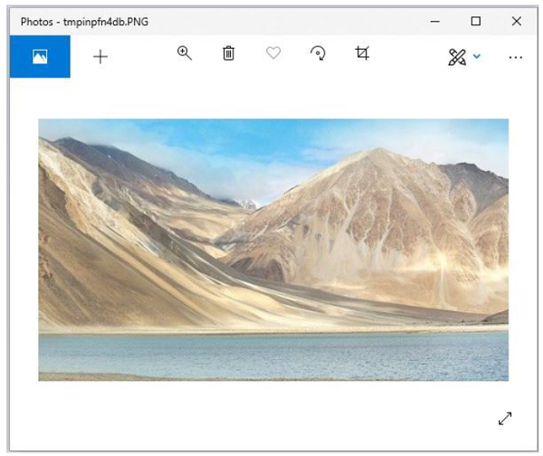

**Output image**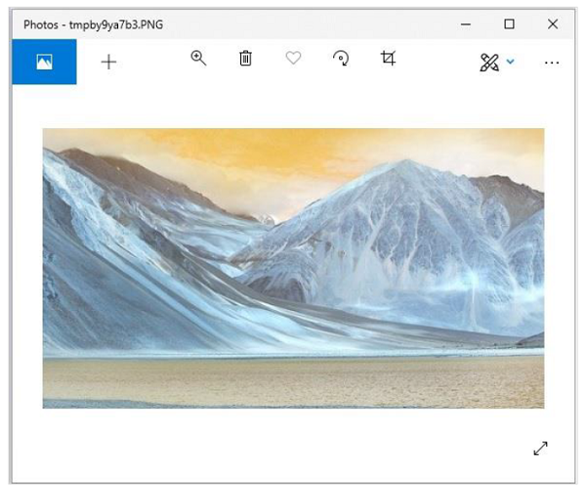

Merging two images

In the same way, to merge two different images, you need to −

* Create image object for the required images using the open() function.
* While merging two images, you need to make sure that both images are of same size. Therefore, get each sizes of both images and if required, resize them accordingly.
* Create an empty image using the Image.new() function.
* Paste the images using the paste() function.
* Save and display the resultant image using the save() and show() functions.

Example

Following example demonstrates the merging of two images using python pillow −

from PIL import Image

#Read the two images

image1 = Image.open('images/elephant.jpg')

image1.show()

image2 = Image.open('images/ladakh.jpg')

image2.show()

#resize, first image

image1 = image1.resize((426, 240))

image1_size = image1.size

image2_size = image2.size

new_image = Image.new('RGB',(2*image1_size[0], image1_size[1]), (250,250,250))

new_image.paste(image1,(0,0))

new_image.paste(image2,(image1_size[0],0))

new_image.save("images/merged_image.jpg","JPEG")

new_image.show()

Output

If you save the above program as Example.py and execute, it displays the two input images and the merged image using standard PNG display utility, as follows −

**Input image1**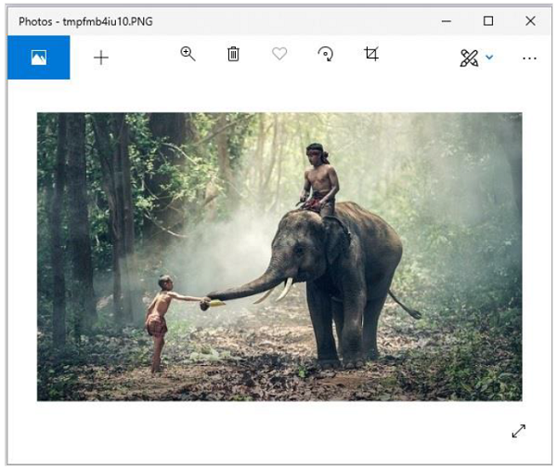

**Input image2**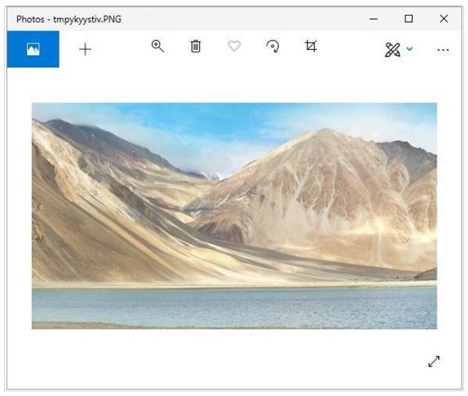

**Merged image**